Rizal Technological University

College of Engineering, Architecture and Technology

**Activity 4**Queue Implementation in Linklist using C++

Subject **:** Data Stucture And Algorithm

Name **:** Art Lisboa

Instructor **: Engr. Ezekiel Nequit**

Date Submitted **: October 31 2020**

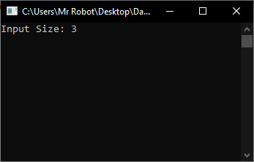

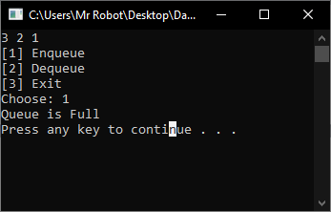

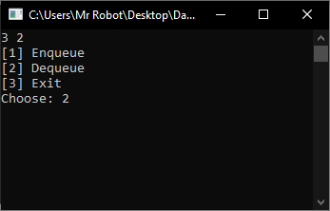

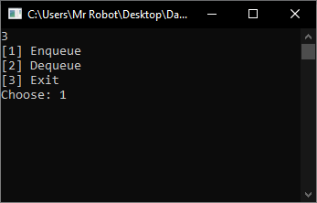

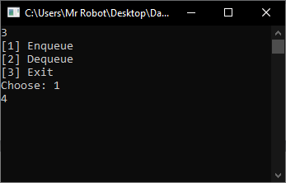

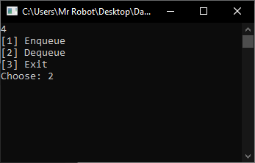

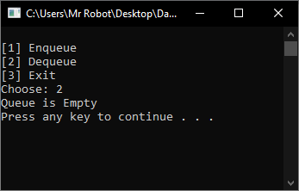

**Source code:**

#include <iostream>

#include<String>

using namespace std;

struct Node {

int data;

struct Node *next;

};

int rear = 0, front = 0, asd = 0;

struct Node* head = NULL; //node

void Enqueue(int new_data) {

Node* new_node = new Node;

new_node->data = new_data;

new_node->next = NULL;

new_node->next = head;

head = new_node;

rear++;

return;

}

void display() {

struct Node* ptr;

ptr = head;

while (ptr != NULL) {

cout << ptr->data << " ";

ptr = ptr->next;

}

return;

}

void Dequeue()

{

int n = rear;

struct Node* temp1 = head;

if (n == 1)

{

head = temp1->next;

delete(temp1);

return;

}

for (int i = 0; i < n - 2; i++){

temp1 = temp1->next;

}

struct Node* temp2 = temp1->next;

temp1->next = temp2->next;

rear--;

delete(temp2);

}

void yeyeye(int size){

system("cls");

string a;

display();

cout << "\n[1] Enqueue ";

cout << "\n[2] Dequeue";

cout << "\n[3] Exit ";

cout << "\nChoose: ";

cin >> a;

if (a == "1") {

if (asd == size)

{

cout << "Queue is Full\n";

system("pause");

return yeyeye(size);

}

else{

cin >> a;

Enqueue(stoi(a));

asd++;

}

}

else if (a == "2"){

if (asd <= 0){

cout << "Queue is Empty\n";

system("pause");

return yeyeye(size);

}

else{

Dequeue();

asd--;

}

}

else if (a == "3"){

system("exit");

}

else{

cout << "Mali ang iyong ininput\n";

system("pause");

}

return yeyeye(size);

}

int main(){

string input;

try{

system("cls");

cout << "Input Size: ";

cin >> input;

yeyeye(stoi(input));

}

catch (exception e)

{

cout << "BOBO!\n";

system("pause");

return main();

}

system("pause");

return 0;

}